

**GravityCore**

**TUTUION CLASS MANAGEMENT SYSTEM**

**GROUP 11**

**Master of Information Technology (MIT)**

**Department of Industrial Management** - **Faculty of Science**

**University of Kelaniya**

**September 2025**

# Team Members

|  |  |
| --- | --- |
| **Name** | **Registration Number** |
| **H M D C Bandara** | **FGS/MIT/2024/056** |
| **K H A Ayesha** | **FGS/MIT/2024/057** |
| **A E Jayakodi** | **FGS/MIT/2024/014** |
| **Wasana PREC** | **FGS/MIT/2024/052** |

# Table of Contents

Team Members 2

Table of Contents 3

Chapter 1: INTRODUCTION 5

1.1 Background 5

1.2 Problem Statement 5

1.3 Objectives 5

1.4 Project Scope 6

Chapter 2: PROJECT MANAGEMENT & REQUIREMENTS 8

2.1 Project management 8

Deployment Strategy 9

2.2 Functional requirements 10

2.3 Non-functional requirements 11

Chapter 3: SYSTEM DESIGN AND IMPLEMENTATION 12

3.1 Technology Stack 12

Libraries Used 12

3.2 system architecture 13

3.3 system models and diagrams 14

High-Level Use Case Diagram: 14

Class Diagram: 15

3.4 interface design 16

3.4.1 Key Interface Elements 16

3.4.2 Screen Layouts 17

3.5 System Testing 20

Chapter 4: Conclusion 21

Chapter 5: Future Enhancements 22

CHAPTER 6: LEARNINGS 23

List of Figures 24

# Chapter 1: INTRODUCTION

## 1.1 Background

GravityEdu is a leading private educational center providing tuition classes for Advanced Level (A/L) students. The institute, known for its focus on student success, has traditionally managed key operations, student data, teacher management, class scheduling, and payments using manual spreadsheets and paper-based processes.

These manual workflows have resulted in several critical challenges:

* Errors in data entry.
* Difficulty in accurately tracking outstanding payments.
* Inefficient generation of reports.
* Time-consuming and high-volume administrative work.

To address these issues and streamline operations, GravityCore, a Python-based Tuition Class Management System, has been developed.

## 1.2 Problem Statement

The educational center is currently struggling with disconnected and manual processes. Using spreadsheets for managing student enrollments, payments, and class schedules is time-consuming and error-prone. This lack of integration makes it difficult to gain a clear, real-time view of finances and overall operational status, which significantly slows down effective decision-making. Furthermore, the increasing administrative workload overwhelms staff with routine tasks, distracting them from their primary goal: supporting students and enhancing the learning experience.

## 1.3 Objectives

The primary objectives of the GravityCore project are:

* To design and develop a centralized, user-friendly management system that automates key processes, creating a single, integrated platform for all tuition center operations.
* To provide comprehensive features including student management, teacher management, class scheduling, payment tracking, and robust reporting capabilities.
* To reduce manual work and significantly improve data accuracy by automating repetitive processes and ensuring consistent, up-to-date information across all modules.

## 1.4 Project Scope

The GravityCore system provides the following core functionalities:

**User Authentication:**

The system provides a secure login mechanism with role based access control to ensure that only authorized users can access the application. Different roles (Admin, Staff/User) are supported, giving each role access only to the features they need. For example, an Admin can manage all data and generate reports, while a regular staff member is not able to manage payment or generate reports. This role-based control keeps data secure and prevents unauthorized changes.

**Teacher Management:**

Allows administrators to create, view, edit, and maintain teacher profiles, including contact details and subject expertise ensuring records stay accurate and up to date.

**Student Management**

The student management module handles the entire student lifecycle. Administrators can register new students with their personal details, update their information when required, and track attendance to monitor participation. It also allows staff to manage tute (study material) distribution so that each student receives the right resources at the right time.

**Class Management**

Class management makes scheduling easy and organized. Classes can be categorized by type (Group or Hall) and purpose (Theory or Revision). Teachers, subjects, and time slots can be assigned, and changes to the timetable can be updated in real-time, reducing confusion and last-minute miscommunication.

**Payment Management**

This module keeps track of all student payments. Administrators can record monthly tuition fees, apply discounts or exemptions where applicable, and instantly see which students have unpaid fees. It also generates detailed outstanding payment reports, helping the institute follow up on pending payments efficiently.

**Batch Processing**

This saves time by allowing administrators to upload large volumes of student data or payment records using CSV files. Instead of entering each record one by one, staff can import data in one go, minimizing manual effort and reducing the chance of typing errors.

**Reports**

The reporting feature provides a clear overview of the center’s operations and finances. Reports can show total income for a selected period, outstanding balances from students who haven’t paid, and statistics on student registrations. These insights help management make informed decisions and plan for future growth.

# Chapter 2: PROJECT MANAGEMENT & REQUIREMENTS

## 2.1 Project management

Effective project management was crucial to the success of the GravityCore system. Key aspects of the project management contribution are outlined below.

To ensure a transparent and efficient workflow, the project utilized **GitHub’s project management features.**

* Tasks were organized into project boards representing specific development phases.
* Each individual task is assigned to team members, and tracked using GitHub’s status indicators.

This approach ensured clear accountability and streamlined progress monitoring, allowing the team to address blockers quickly and stay up to date.

**GitHub Repository:**

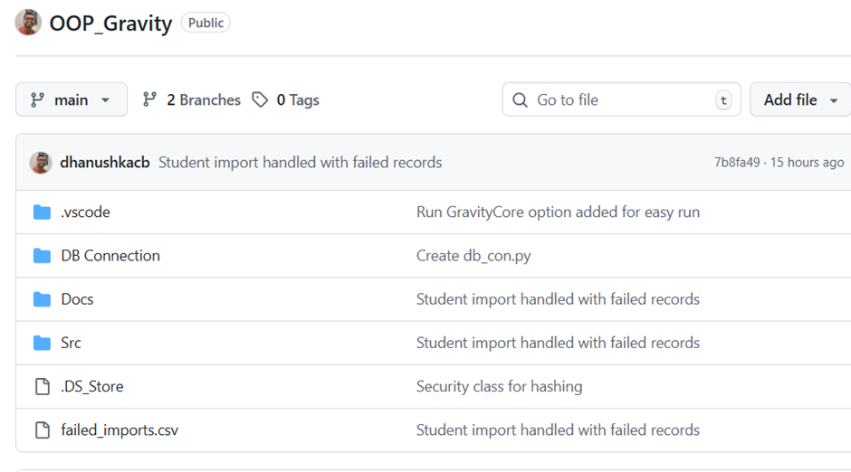

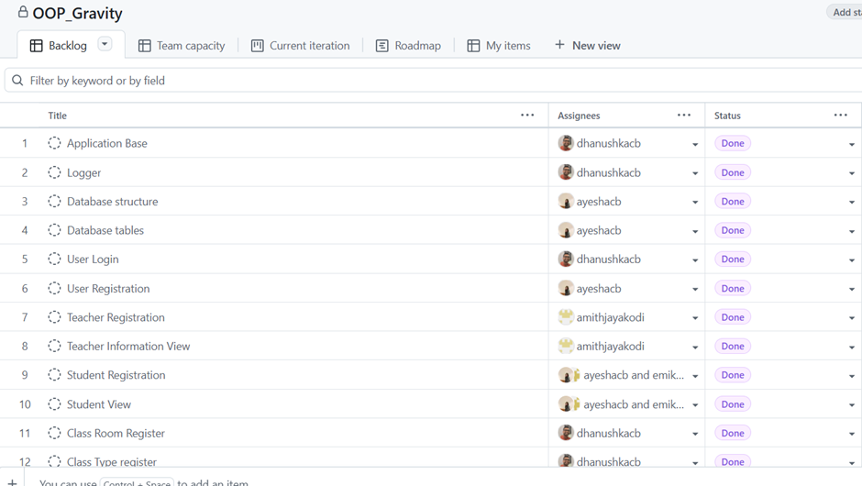

### Deployment Strategy

The system follows a structured deployment process:

* **Development Workflow:** Utilizes Version Control with feature branching, pull requests, and a code review process. The aim is to implement Continuous Integration (CI).
* **Deployment Environments:** Includes distinct Development and Production environments.
* **Database:** A plan is in place for database migrations and for Backup and Recovery to ensure data safety and availability.

## 2.2 Functional requirements

These define what the system must do to meet the user's needs:

1. **User/Admin Management:**
   * The system shall allow users (Admins and Staff) to log in with a username and password.
   * The system shall allow Admins to add, edit, and delete user accounts.
2. **Teacher Management:**
   * The system shall allow adding new teachers with necessary details.
   * The system shall allow viewing, editing, and deleting teacher records.
3. **Student Management:**
   * The system shall allow registering students with details (Name, Reg Year/Month, Contact, Email, Stream, Discount %).
   * The system shall allow updating or deleting student details.
   * The system shall allow bulk import of student details via CSV upload.
4. **Class & Attendance:**
   * The system shall allow scheduling classes with Subject, Teacher, Type (Group/Hall), Category (Theory/Revision), Time slot, and Classroom.
   * The system shall allow editing or deleting scheduled classes.
   * The system shall allow marking student attendance for each class session.
5. **Payment & Reporting:**
   * The system shall allow recording monthly tuition fee payments.
   * The system shall automatically apply discounts/exemptions when calculating payments.
   * The system shall provide functionality for generating reports (Total income, Outstanding balances, Student-wise payment history).

## 2.3 NON-FUNCTIONAL requirements

These define the quality attributes and constraints under which the system must operate:

* **Performance:** The system shall be capable of supporting concurrent users efficiently.
* **Scalability:** The system shall support multiple tier levels to accommodate growth and increased demand.
* **Security:** The system shall incorporate encrypted credentials (password hashing) and role-based access control (RBAC).
* **Usability:** The system shall feature a consistent and intuitive GUI using Tkinter and easy navigation.
* **Maintainability:** The system shall adopt a modular code design to facilitate smooth updates and enhancements.
* **Reliability:** The system shall aim for 99.9% uptime and perform daily backups to ensure data safety.

# chapter 3: SYSTEM DESIGN AND IMPLEMENTATION

## 3.1 Technology Stack

GravityCore is built using a robust, modern technology stack:

|  |  |  |
| --- | --- | --- |
| **Component** | **Technology** | **Description** |
| Frontend (View) | Tkinter (Python GUI) | Used to develop the desktop graphical user interface. |
| Backend (Controller) | Python | Implements the core application logic and business rules. |
| Database (Model) | MySQL | The relational database used for persistent data storage. |

### Libraries Used

The core functionality is supported by the following libraries:

* **Tkinter/ttk:** Standard Python libraries for the GUI framework and modern themed widgets (Combobox, Treeview).
* **mysql-connector-python:** For database connectivity and executing SQL queries.
* **bcrypt** (or hashlib): Used for password hashing to secure user credentials.
* **CSV, os, datetime:** Standard libraries for bulk imports/exports, file handling, and timestamping.

## 3.2 system architecture

### The project follows a modular, layered architecture based on the Model-View-Controller (MVC) design pattern, ensuring a clear separation of concerns to improve maintainability, testability, and scalability.

### Architecture Layers

1. **Model Layer (Data Access):**
   * **Purpose:** Handles all database operations, data access, and core business logic.
   * **Examples:** Classes like Users, Students, Attendance that encapsulate SQL queries and data manipulation (e.g., located in Schema.py, Connection.py).
2. **View Layer (User Interface):**
   * **Purpose:** Manages the user interface using Tkinter, displays forms, tables, and handles user input.
   * **Examples:** GUI classes such as UserRegistration.py, ClassRoomRegister.py, ImportStudentData.py.
3. **Controller/Process Layer (Application Logic):**
   * **Purpose:** Orchestrates the flow between the view and model, processes user actions, and coordinates data import/export.
   * **Examples:** Classes like BaseRegistration, StudentAttendanceProcess, and report generators.
4. **Utility/Config Layer:**
   * **Purpose:** Provides essential utilities for configuration, security (e.g., password hashing), and logging.

* **Examples:** Settings.py, Security.py, Logger.py.

## 3.3 system models and diagrams

These diagrams visually represent the static and dynamic structure of the system.

### High-Level Use Case Diagram:

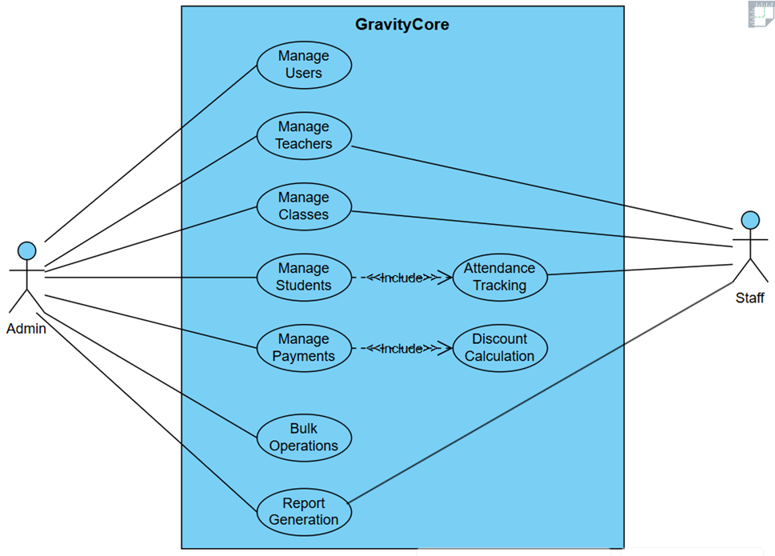

### Class Diagram:

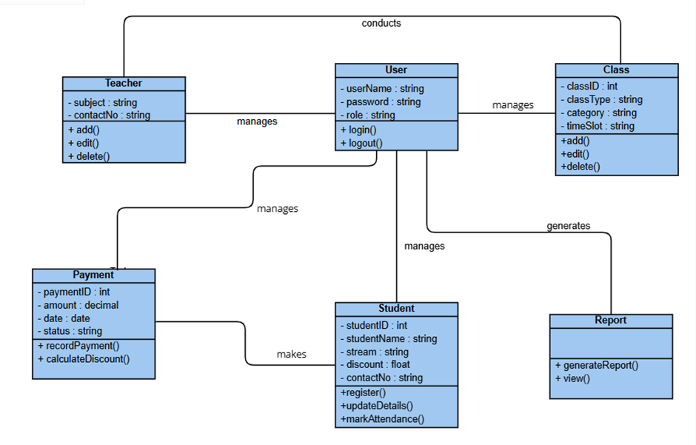

## 3.4 interface design

The system is implemented as a **desktop GUI application** using Python Tkinter, following a form-based navigation model.

### 3.4.1 Key Interface Elements

**Login Window:** Features username and password entry fields with role-based authentication.

**Main Dashboard:** Provides a clear menu or navigation panel for accessing modules (Users, Teachers, Students, Classes, Payments, Reports).

**Data Display:** Utilizes ttk.Treeview tables for viewing lists of records and includes columns for Edit/Delete actions.

**Forms:** Uses standard Tkinter Entry widgets and ttk.Combobox for data input and selections.

**Dialogs:** Employs messagebox for confirmations, errors, and success messages.

**Reports Interface:** Features Treeviews for data display, filters (month, year, teacher), and export options (CSV/TXT).

### Screen Layouts

1. **User Login**

Provides fields for username and password input, with role-based authentication. Incorrect login attempts trigger an error message.

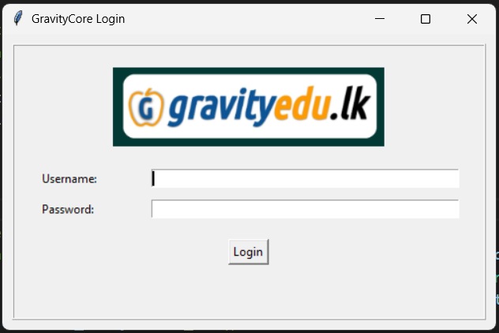

1. **User Registration**

Allows Admins to create, edit, and delete system user accounts. Includes fields for username, password, and role selection (Admin/Staff).

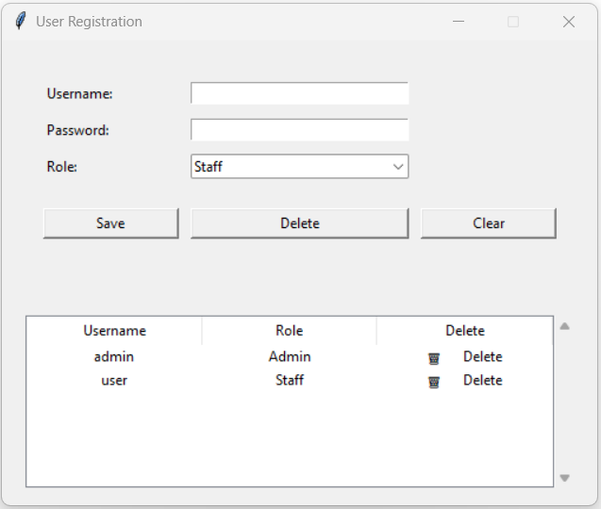

1. **Class Scheduling**

Allows scheduling of classes with fields for Subject, Teacher, Category (Theory / Revision), Type (Group/Hall), Date/Time, and Classroom. Detects and warns about schedule conflicts.

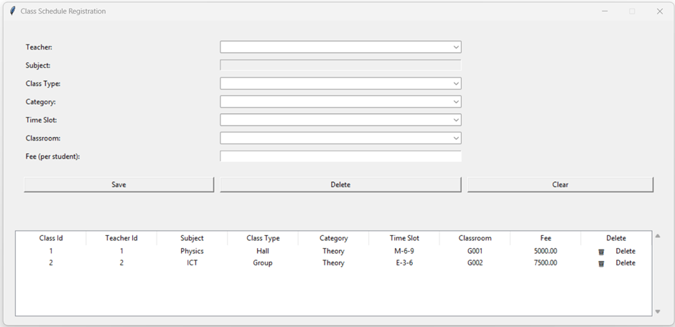

1. **CSV Upload and Process**

Provides a file upload option to import student data or payment records from CSV files. Displays a summary of imported records and any errors encountered. Allows the user to process the files.

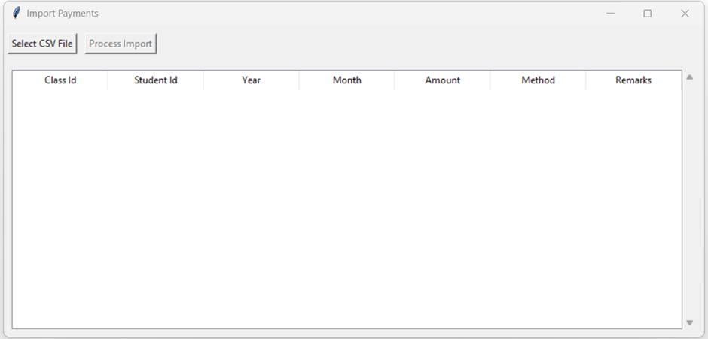

1. **Report Generation**

Generates reports such as total income, outstanding payments, and student-wise payment history. Provides filtering options (month/year) and export as TXT files.

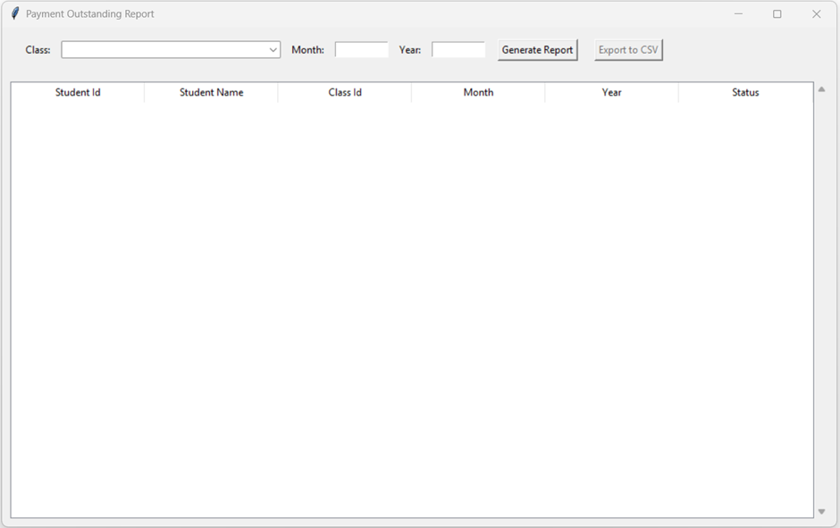

## System Testing

System testing was performed to ensure the system meets all specified functional requirements. Below are key test scenarios:

|  |  |  |  |
| --- | --- | --- | --- |
| **Test Case ID** | **Module** | **Test Scenario** | **Expected Result** |
| TC-01 | User Authentication | Login with valid admin credentials. | Admin is successfully logged in and redirected to the main window. |
| TC-02 | User Authentication | Login with invalid credentials. | The system displays an error message and prevents login. |
| TC-03 | Teacher Management | Add a new teacher. | A new teacher is added and visible in the teacher list. |
| TC-04 | Student Management | Add a new student. | A student is added and visible in the student list. |
| TC-05 | Class Management | Schedule a new class. | Class is scheduled and appears in the timetable without conflicts. |
| TC-06 | Payment Management | Record student fee. | Payment is recorded and balance updated correctly. |
| TC-07 | Batch Processing | CSV upload for students' attendance. | The system successfully imports student records and saves them in the database. |
| TC-08 | Reports | Generate outstanding payments report. | The report is displayed correctly with accurate outstanding balances. |

# Chapter 4: Conclusion

GravityCore represents a significant step forward in modernizing the tuition center's operations. By successfully digitizing and centralizing key processes—including student registration, class scheduling, payment tracking, and reporting—the system effectively eliminates the inefficiencies and errors inherent in the previous manual, paper-based workflows.

The system's user-friendly Tkinter interface ensures a quick staff adaptation, while the underlying MVC architecture provides a solid, maintainable foundation for scalability and future feature expansion. The automation of routine tasks dramatically reduces administrative workload and ensures that critical information is consistently accurate and accessible.

Crucially, the powerful reporting capabilities offer management real-time insight into income and outstanding payments, enabling faster and better-informed decision-making.

Ultimately, GravityCore allows the GravityEdu team to shift their focus from time-consuming paperwork toward their core mission: delivering high-quality education and supporting student success. This system positions the institute for sustainable growth, improved operational efficiency, and an enhanced experience for all stakeholders.

# Chapter 5: future Enhancements

The following features are identified as potential improvements for future versions of GravityCore:

* **QR-Based Attendance Marking:** Replace manual attendance marking with QR code scanning for faster, contactless attendance tracking.
* **SMS/Email Notifications:** Automatically notify students/parents about outstanding payments, class reschedules, or important announcements.
* **Student/Parent Portal:** Provide a secure web portal where students and parents can view attendance history, payment records, and class schedules.

# CHAPTER 6: LEARNINGS

**Strengthen technical skills:**

During the development of **GravityCore**, I strengthened several key technical skills:

* **Layered Architecture:** Learned to separate concerns effectively, building modular, maintainable, and scalable applications by organizing code into Models (data handling), Views (Tkinter UI), and Controllers (logic flow).
* **Database Design & MySQL Integration:** Designed ER diagrams, normalized tables, implemented relationships, and wrote SQL queries (CRUD, joins, reports) to manage student, teacher, class, and payment data efficiently.
* **GUI Development with Tkinter:** Built intuitive, form-based interfaces with Treeviews, entry fields, and navigation panels, improving user experience and reducing errors.

**Problem-Solving:**

Improved analytical skills by troubleshooting database connection issues, UI glitches, and logic errors during development.

**Time Management:**

Learned to plan sprints, set realistic deadlines, and deliver features on time.

**Communication & Documentation:**

Enhanced the ability to write clear technical documentation and communicate progress to stakeholders.

# List of Figures